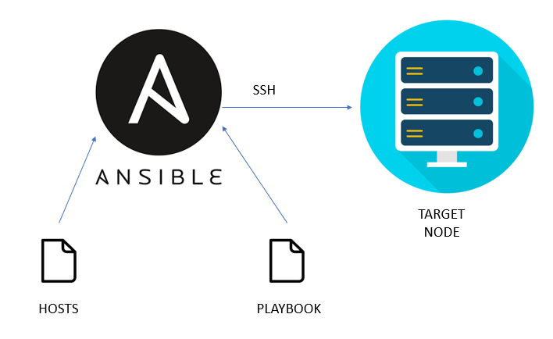
Task Title
Ansible Challenge
Objective
The objective of this challenge is to execute the tasks posted on slack and worked on executing the Ansible tasks as per requirements.
Prerequisites
List all requirements before starting:
- Master Controller server
- Nodes- workers
- Variables types of variables
- Playbook
- Ad hoc commands
- Jenkins
- Terraform
Issues Faced: Briefly mention issues and how you fixed them. Posted below in the last.
Conclusion
Conclusion has been provided for every task at the end.
Tasks
Create ci pipeline that will deploy and configure these VMs using terraform and ansible according following requirements
- Deploy 2 virtual machines using terraform.
  - first vm on Amazon linux, hostname: c8.local
  - second vm on ubuntu 21.04, hostname: u21.local

Architecture
- VM 1: Amazon Linux 2 → hostname c8.local
- VM 2: Ubuntu 21.04 → hostname u21.local

Prerequisites
- AWS account
- IAM user with EC2 permissions
- AWS CLI configured (aws configure)
- Terraform installed

File Structure
terraform-vms/
│── main.tf
│── variables.tf
│── outputs.tf

variables.tf

variable "region" {
default = "us-east-1"
}

variable "instance_type" {
default = "t3.micro"
}

variable "key_name" {
description = "Existing AWS key pair name"
}
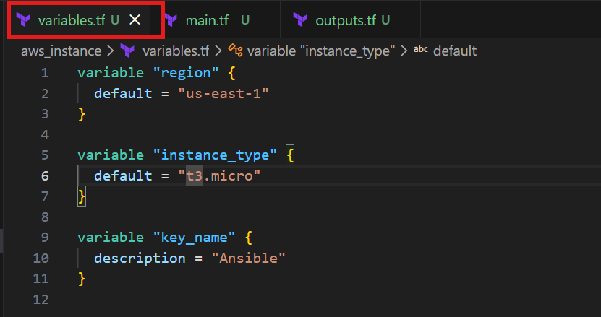

main.tf

provider "aws" {
region = var.region
}

# Amazon Linux 2 AMI
data "aws_ami" "amazon_linux" {
most_recent = true
owners = ["amazon"]

filter {
name = "name"
values = ["amzn2-ami-hvm-*-x86_64-gp2"]
}
}

data "aws_ami" "ubuntu_22" {
most_recent = true
owners = ["099720109477"]

filter {
name = "name"
values = ["ubuntu/images/hvm-ssd/ubuntu-jammy-22.04-amd64-server-*"]
}
}

# Ubuntu 20.04 AMI
data "aws_ami" "ubuntu_20" {
most_recent = true
owners = ["099720109477"]

filter {
name = "name"
values = ["ubuntu/images/hvm-ssd/ubuntu-focal-20.04-amd64-server-*"]
}
}

# Amazon Linux VM
resource "aws_instance" "amazon_vm" {
ami = data.aws_ami.amazon_linux.id
instance_type = var.instance_type
key_name = var.key_name

user_data = <<-EOF
#!/bin/bash
hostnamectl set-hostname c8.local
EOF

tags = {
Name = "c8.local"
}
}

# Ubuntu 21.04 VM
resource "aws_instance" "ubuntu_vm" {
ami = data.aws_ami.ubuntu_20.id
instance_type = var.instance_type
key_name = var.key_name

user_data = <<-EOF
#!/bin/bash
hostnamectl set-hostname u21.local
EOF

tags = {
Name = "u21.local"
}
}

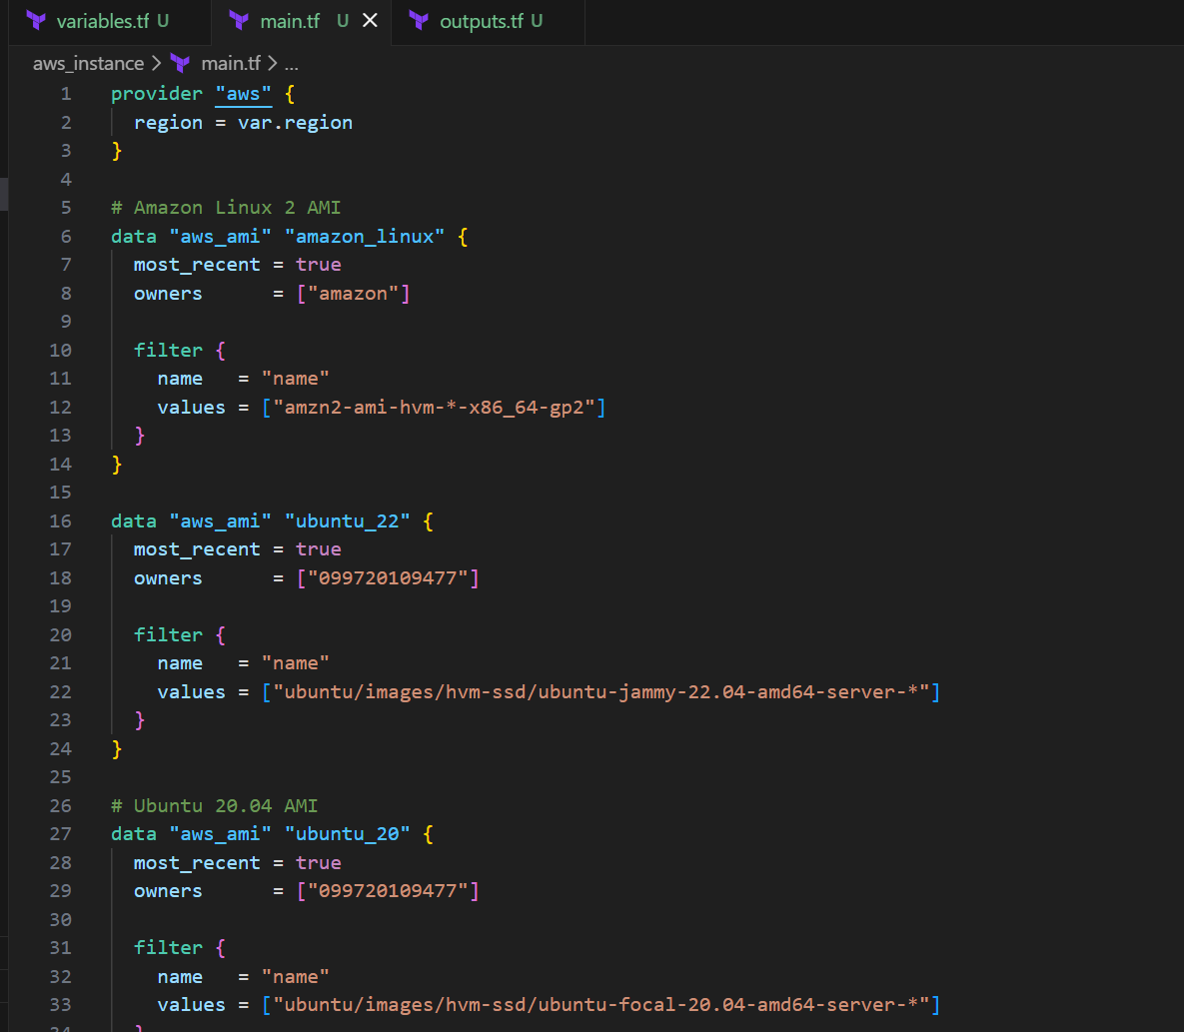
outputs.tf

output "amazon_linux_ip" {
value = aws_instance.amazon_vm.public_ip
}

output "ubuntu_21_ip" {
value = aws_instance.ubuntu_vm.public_ip
}
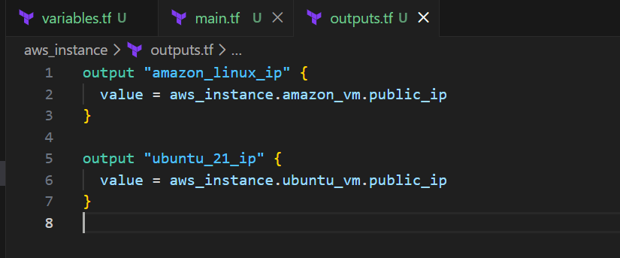

Deploy Commands

terraform init
terraform plan -var="key_name=Ansible"
terraform apply -var="key_name=Ansible"
Terraform init
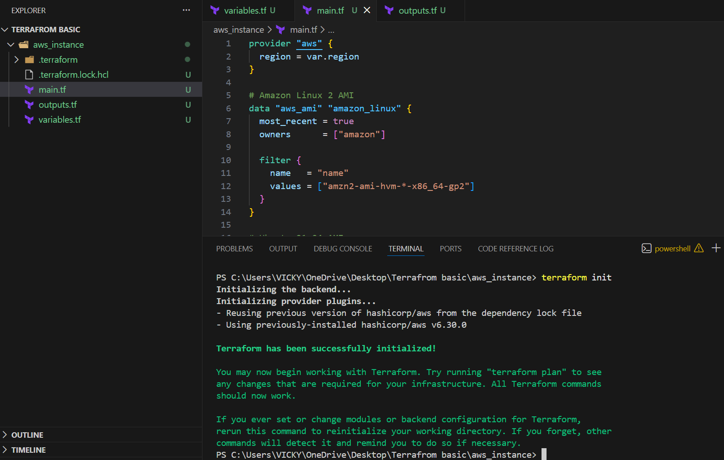

Terraform plan
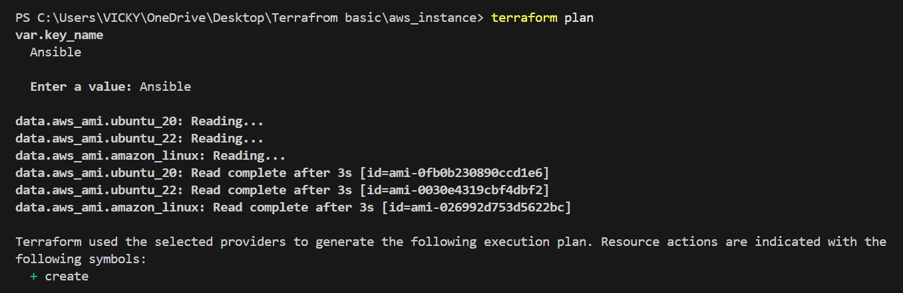

Terraform apply
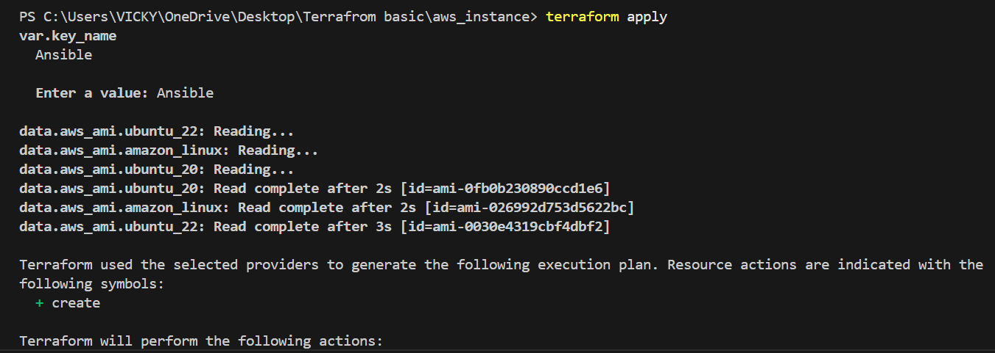
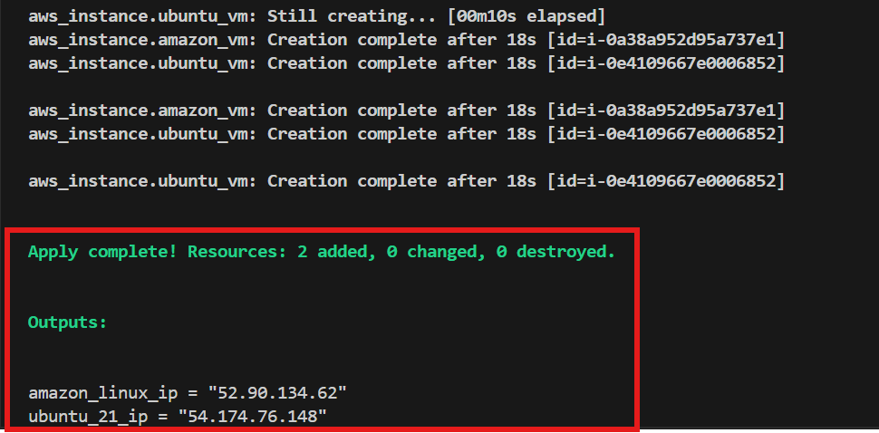

Let’s verify if the VM’s were installed

Issues faced:
Aws configure should be done to communicate with aws provider.
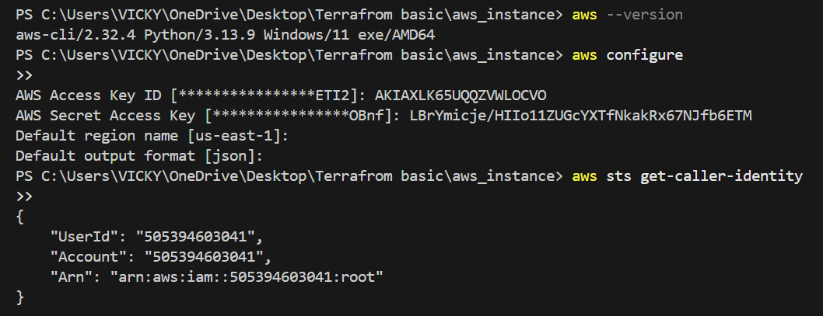

- As a result of terraform execution, dynamically create inventory for ansible
  - c8.local should be in the frontend group
  - u21.local should be in the backend group
- Create ansible playbook for c8.local and u21.local
- for linux OS playbook should apply the following changes
  - selinux: disable
  - firewalld: disable
- for frontend playbook group should install and configure nginx
  - nginx configuration should do proxying from port 80 on port 19999 to the
  - backend group
- for the backend group, the playbook must install the Netdata application from the
  - official repositories and run it on port 19999.

